Page URL - https://rootcabs.com/taxi-in-vellore/
Url Slug Suggestion - https://rootcabs.com/cities/taxi-in-vellore
Primary Keyword

taxi service in vellore
cab service in vellore
Secondary Keyword
call taxi vellore
cabs in vellore
vellore taxi
cab booking vellore
taxi in vellore
vellore taxi cab service
one way drop taxi vellore
vellore to chennai cab
vellore taxi
cab booking vellore
drop taxi vellore
cab booking in vellore
online cab booking in vellore
vellore call taxi service
vellore to chennai cab
vellore car rental
vellore drop taxi
cabs in vellore
cabs near cmc hospital vellore
cab service near cmc vellore
Page Layout


Include the keyword taxi service service in vellore in the header.
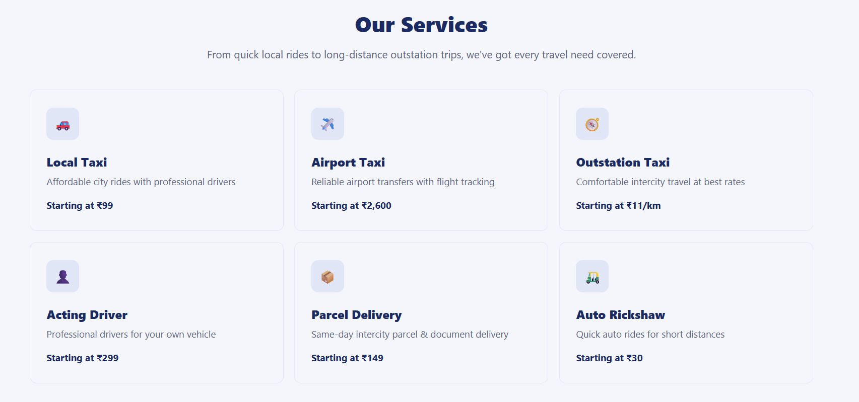

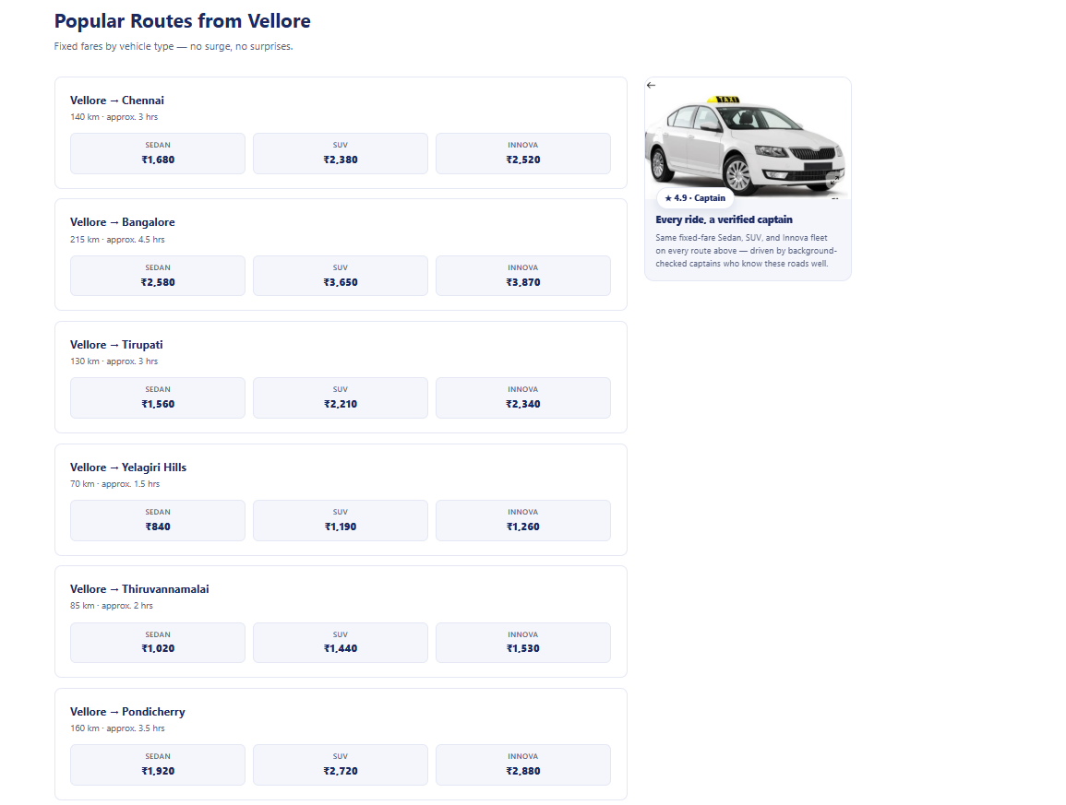

Image content - needed for this

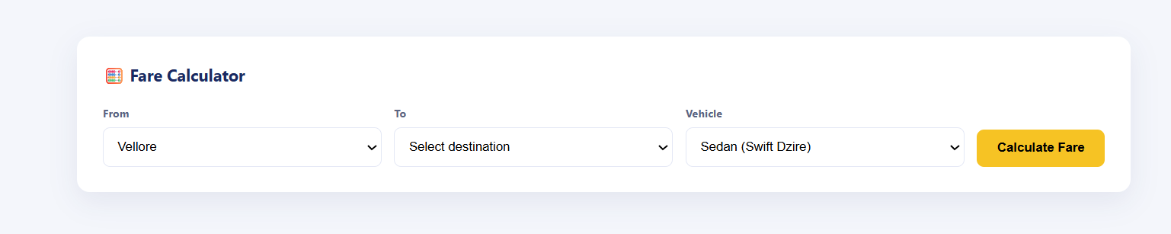

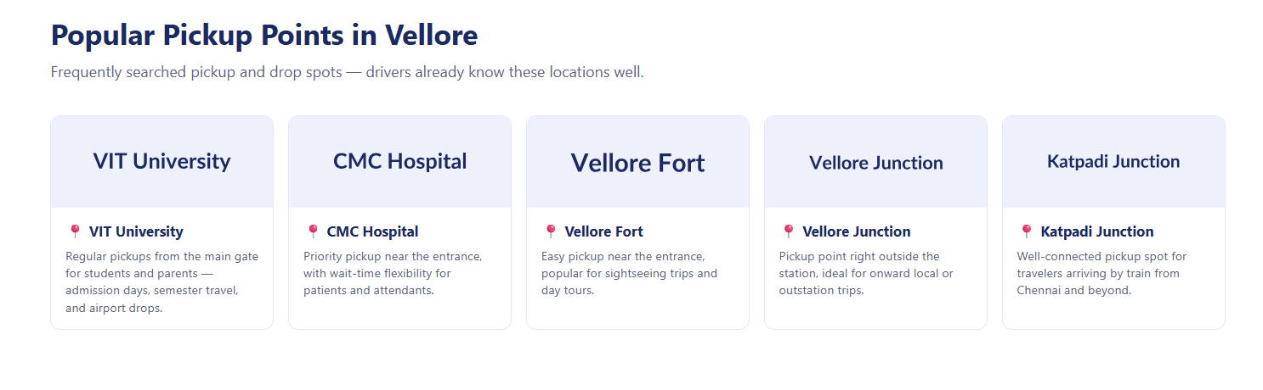

Follow the same as - Chennai location page.

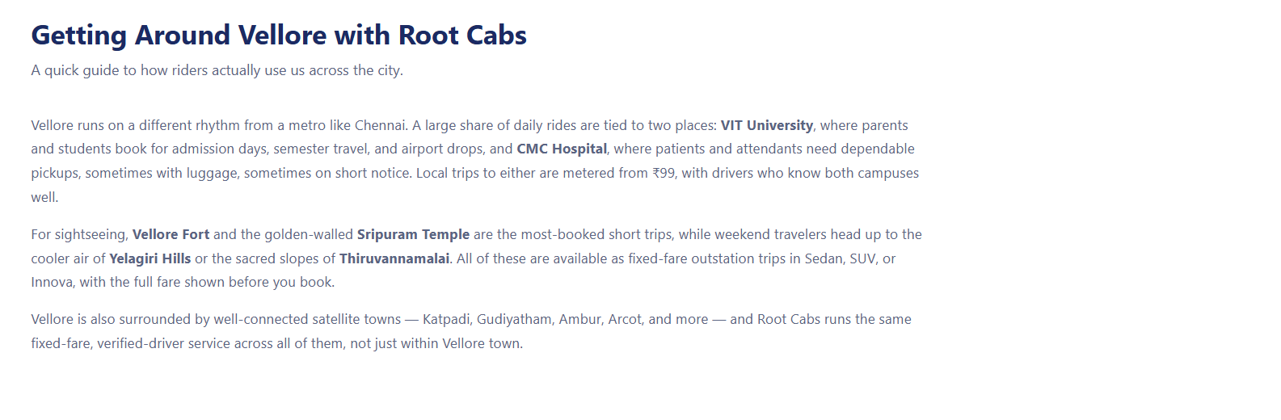
Follow the same as - Chennai location page.

Refer this - https://www.redtaxi.co.in/taxi-services-in-vellore

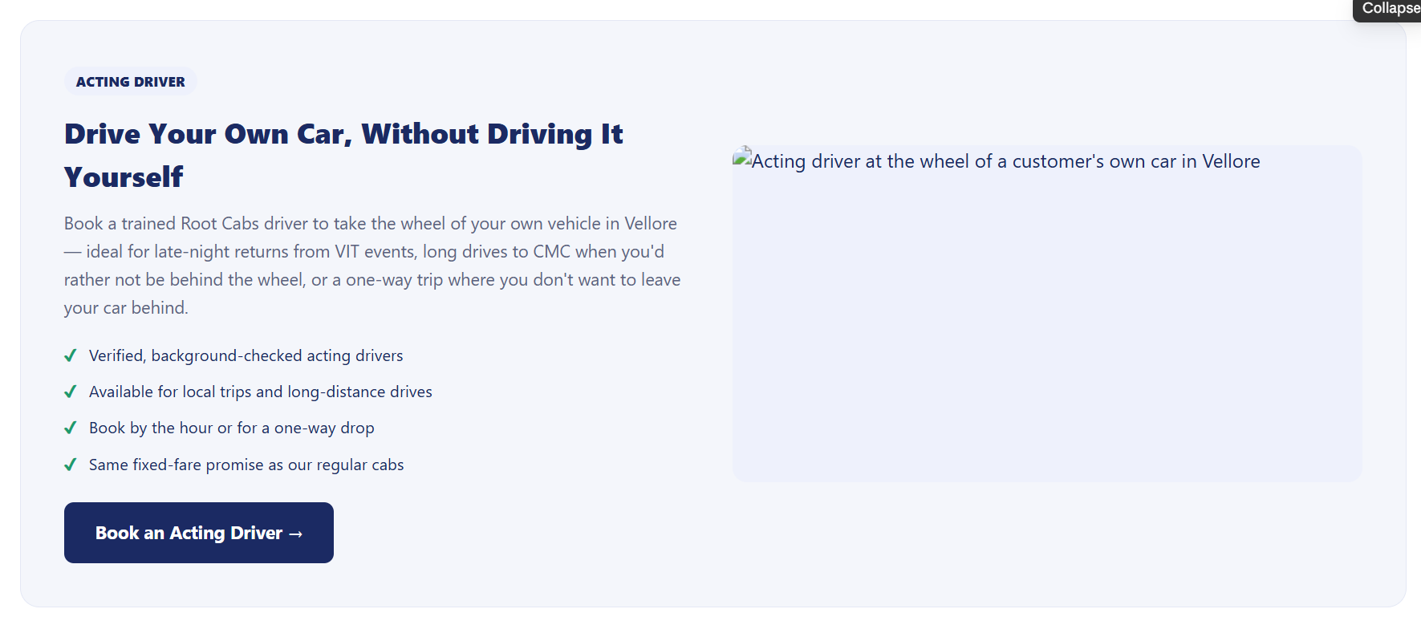

Acting driver section added - Purpose interlinking to the acting driver page.
Keywords
acting driver in vellore
acting driver jobs in vellore
vellore acting driver
hire a driver in vellore
get a driver in vellore
car driver service in vellore

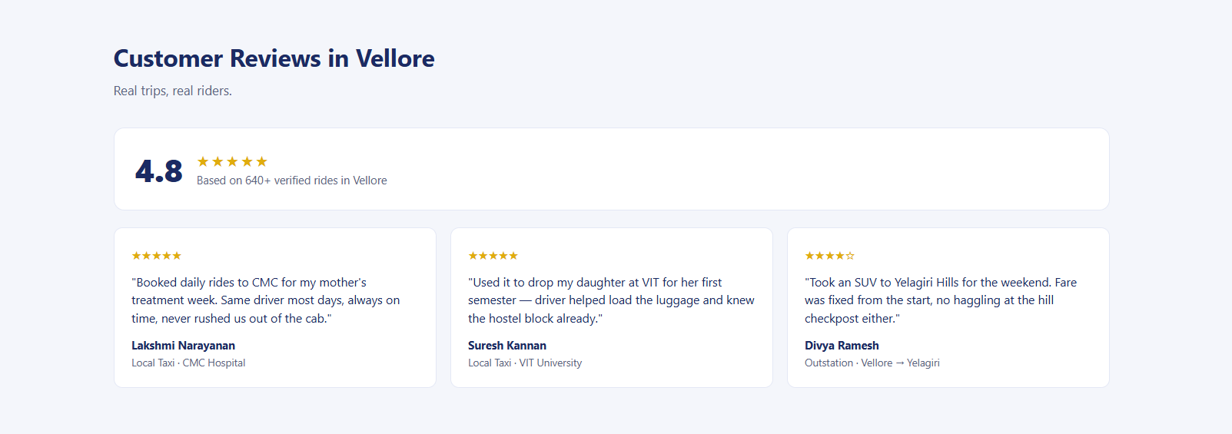

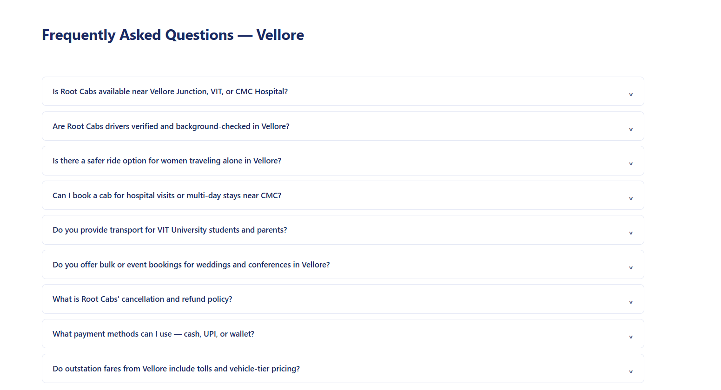

Which is the best taxi service in Vellore?
How do I book a taxi in Vellore with Root Cabs?
Are Root Cabs available 24x7 in Vellore, even during festivals?
Which app should I use to book a cab in Vellore?
Are Root Cabs available near Vellore Junction, VIT University, or CMC Hospital?
Are Root Cabs drivers verified and background-checked in Vellore?
What should I do if I can't find my driver at the pickup point?
Is there a safer ride option for women traveling alone in Vellore?

